Enable the change data capture in SQL server

CREATE DATABASE New_Source_DB

USE [New_Source_DB];

GO

EXEC sp_changedbowner 'Madhu'

GO

-- Create a Users table

CREATE TABLE Users

(

ID int NOT NULL PRIMARY KEY,

FirstName varchar(30),

LastName varchar(30),

Email varchar(50)

)

-- Enable Database for Change data capture

USE New_Source_DB

GO

EXEC sys.sp_cdc_enable_db

GO

-- ======================

-- Enable a Table for CDC

-- ======================

USE New_Source_DB

GO

EXEC sys.sp_cdc_enable_table

@source_schema = N'dbo',

@source_name = N'Users',

@role_name = N'Madhu',

@filegroup_name = N'',

@supports_net_changes = 1

GO

EXEC sp_configure 'clr enabled';

EXEC sp_configure 'clr enabled' , '1';

RECONFIGURE;

-- Check that CDC is enabled on the database

SELECT name, is_cdc_enabled

FROM sys.databases WHERE database_id = DB_ID();

INSERT INTO Users Values (1, 'Jorge', 'Ramos', 'ramos@yahoo.com')

INSERT INTO Users Values (2, 'Andrew', 'Strudwick', 'andrew@yahoo.com')

INSERT INTO USERS Values (3, 'Thomas', 'Tuchel', 'tuchel@gmail.com')

-- Query the results of the changes captured

SELECT * FROM [cdc].[dbo_Users_CT]

GO

DELETE FROM Users WHERE ID = 1

UPDATE Users SET LastName = 'Snow' WHERE ID = 2

DELETE FROM Users WHERE ID = 3

select * from sys.dm_cdc_log_scan_sessions

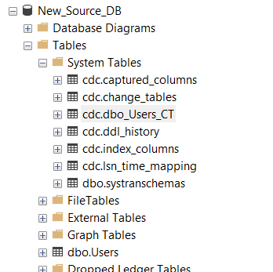

**How to enable existing database**

Use CMS;

EXEC sys.sp_cdc_enable_db;

USE CMS

GO

EXEC sys.sp_cdc_enable_table

@source_schema = 'dbo',

@source_name = 'EmployeeData',

@role_name = null,

@supports_net_changes = 0;

USE CMS

GO

select name, is_cdc_enabled

from sys.databases where name = 'CMS'

GO

USE CMS

GO

select name,type,type_desc,is_tracked_by_cdc

from sys.tables

where name = 'EmployeeData'

GO

select name, is_tracked_by_cdc from sys.tables

where is_tracked_by_cdc= 1

Disbale the CDC

EXEC sys.sp_cdc_disable_db;